**ASG using cloud watch**

Step 1: create a lauch template

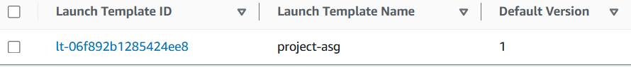

Step 2: create asg

1. Choosing launch template

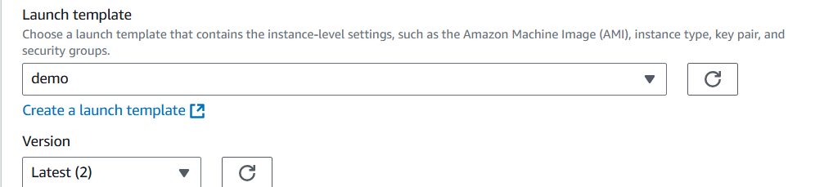

1. Choosing instance options

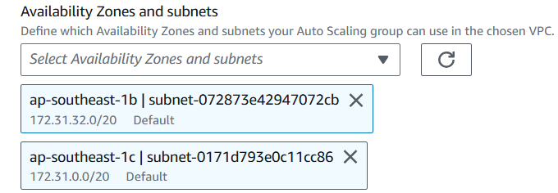

1. Advanced config:

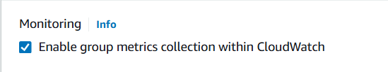

1. Configuring group size

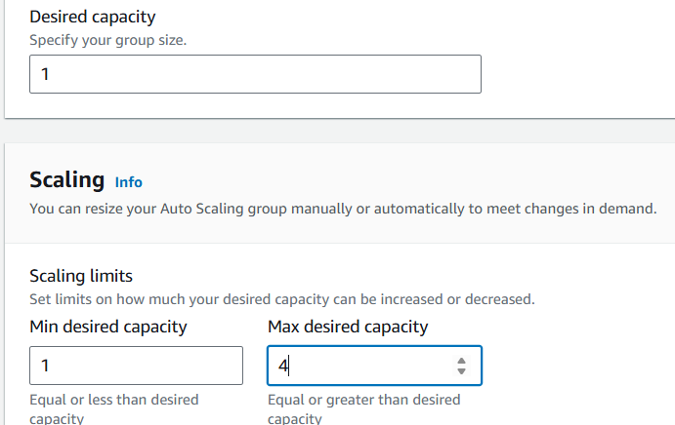

1. Add notification by creating SNS

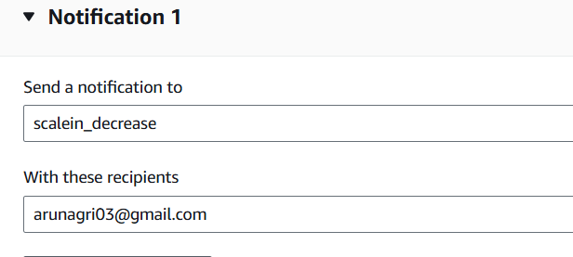

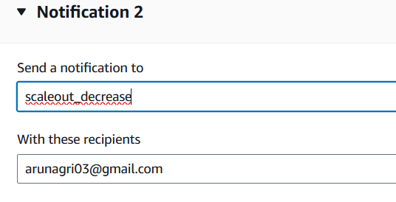

Step 3: go to SNS and check the topics has created



Confirm subscription on your mail

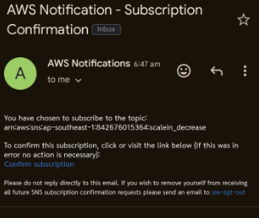

Step 4: Go to cloud watch and create alarm

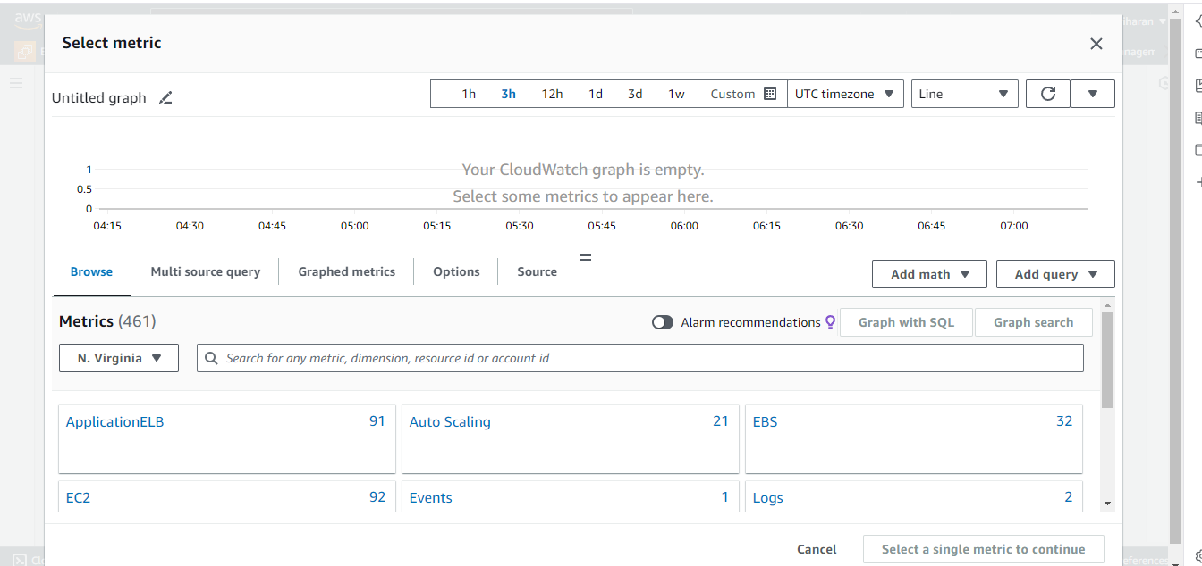

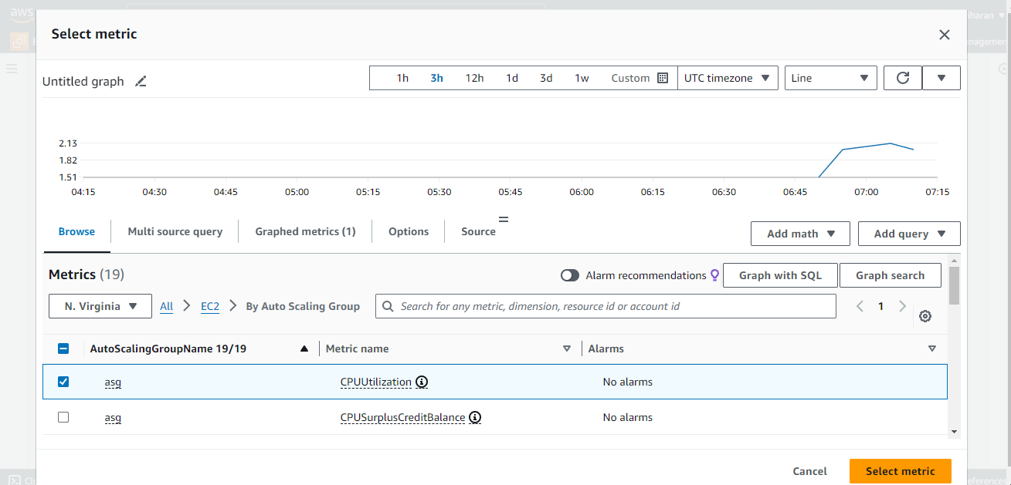

Create alarm -> select metric -> EC2 -> by auto-scaling group -> cpu - utilization



Specify the conditions

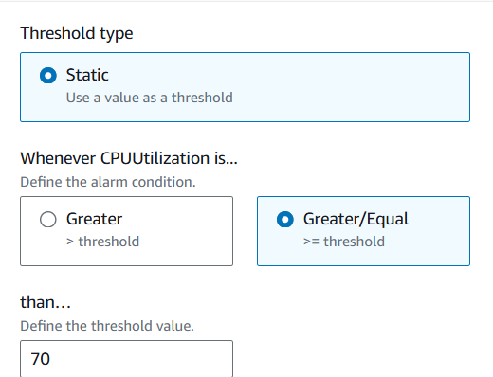

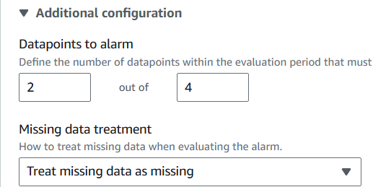

Then choose the SNS topic (scale in – increase)

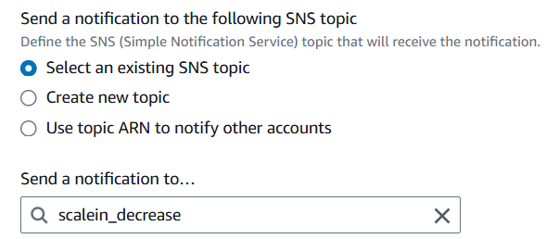

Set alarm name and description

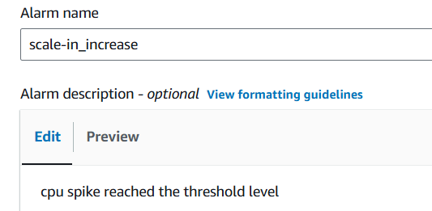

At the same way create alarm for scale-out(decrease)

After creating alarm, it shows in dashboard

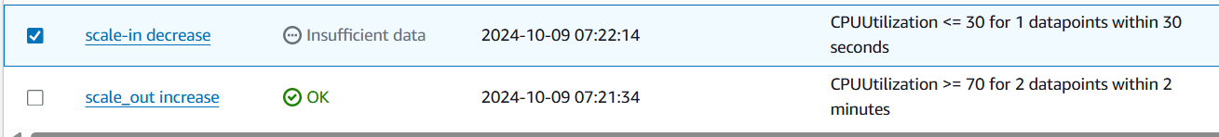

Then you go to autoscaling group

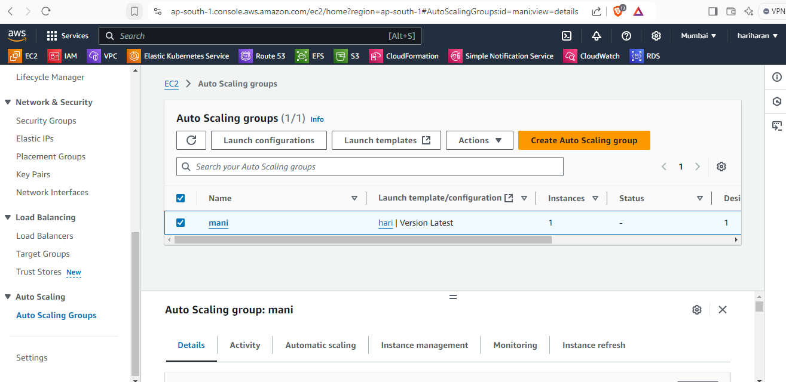

Autoscaling to create dynamic policy

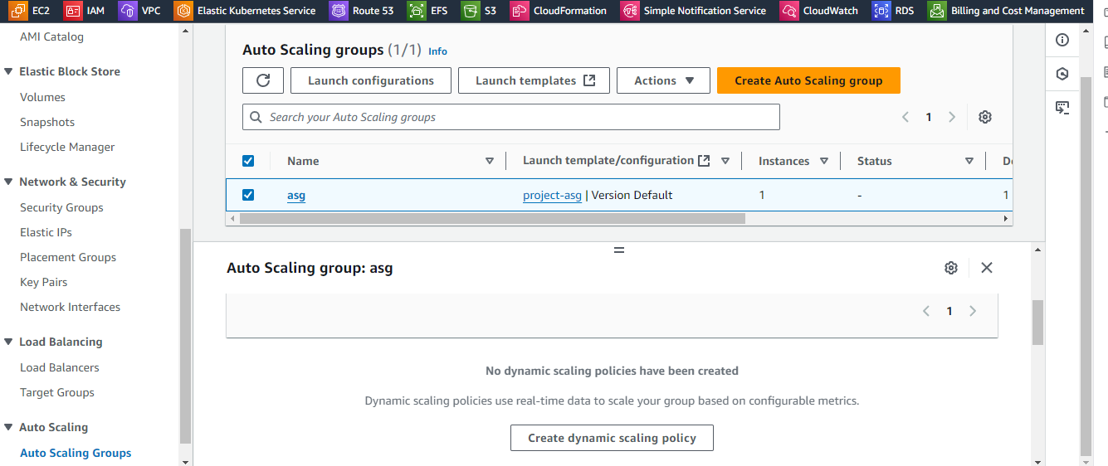

Step 5: same way create scaling policy for scale-out {chose simple tracking}

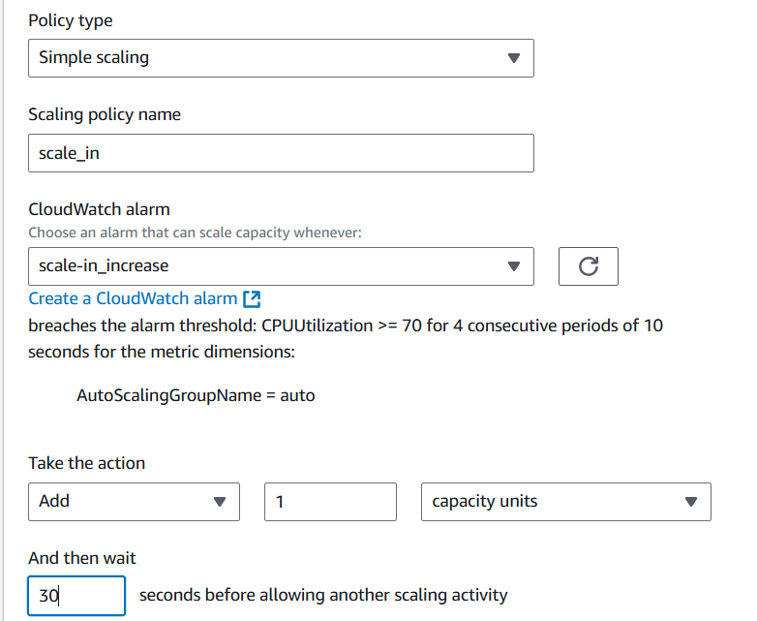

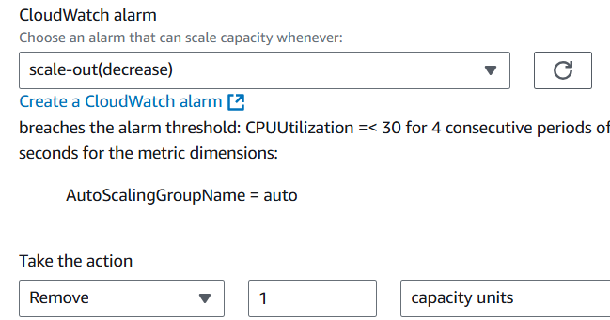

Step 6:

Go to the instance and increase the cpu utilization



After running dd command check in the activity of autoscaling group

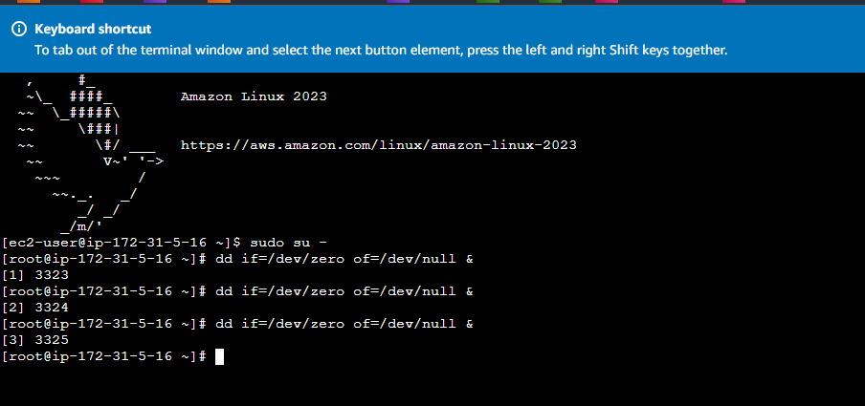

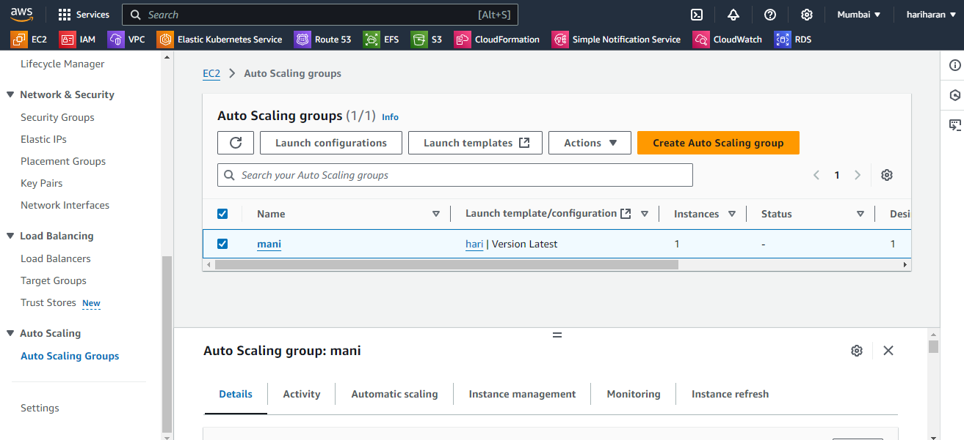

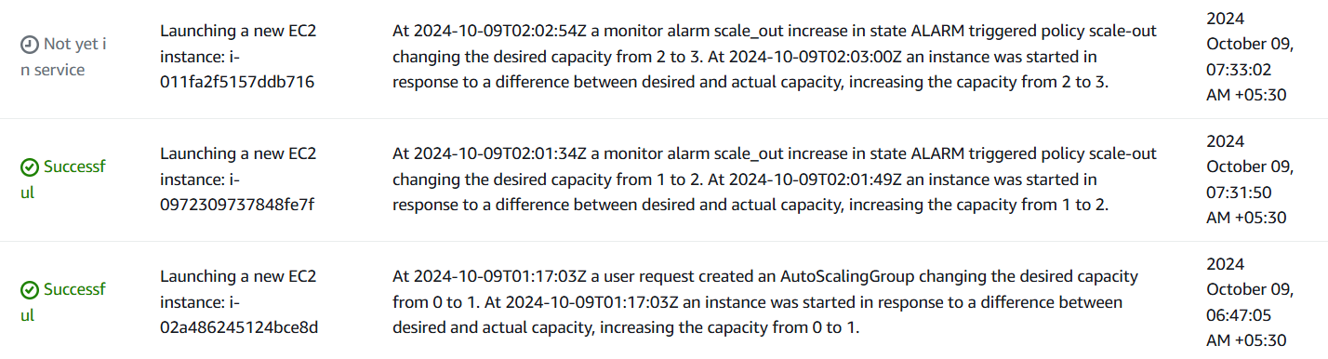

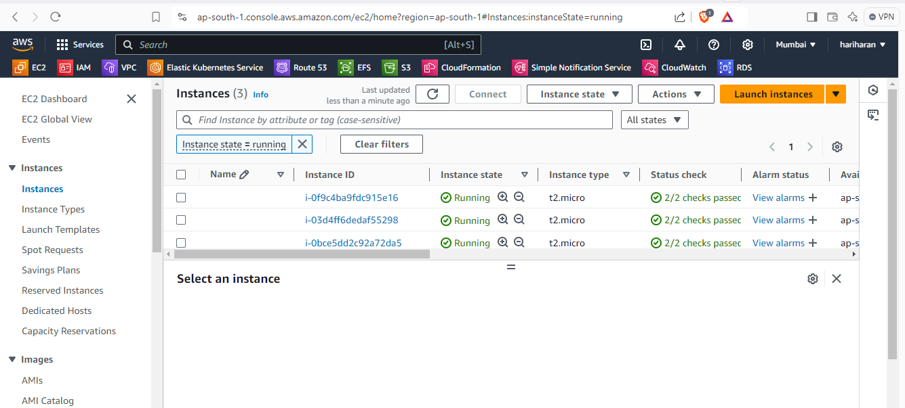

After deleting the dd command in instance scale-in takes place

